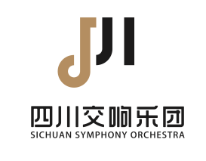 **Application Form for Recruitment**

**of Sichuan Symphony Orchestra**

|  |  |  |  |  |  |
| --- | --- | --- | --- | --- | --- |
| Name |  | Birthday | |  | Photo |
| Gender |  | Nationality | |  |
| Degree |  | | | |
| Tel./Email |  | | | |
| Education  (Please indicate year of graduation) |  | | | | |
| Passport No. |  | | | | |
| Major |  | | | | |
| Position Applying For |  | | | | |
| Do you accept adjustments | | | □YES □NO | | |
| Resume |  | | | | |
| Awards and Certifications |  | | | | |

|  |
| --- |
|  |
|  |